Design Sprint 1 individual

1. 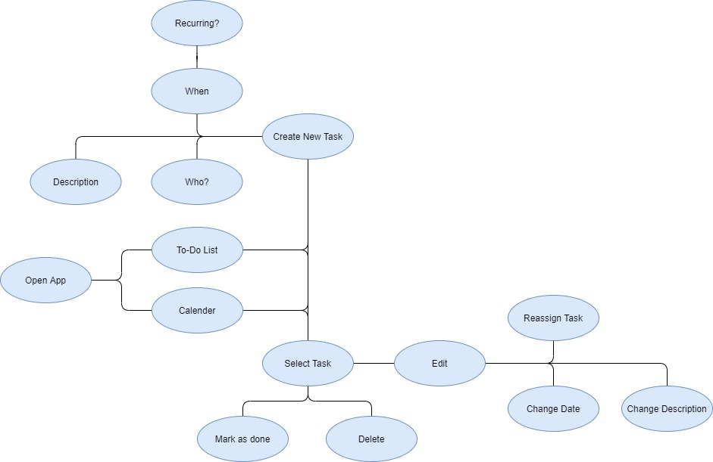Map:
2. User Story

Steve wants to keep his apartment cleaner, but his roommate Leroy is a bit of a messy person. Leroy is always forgetting to put stuff away, take the trash out I time as well as leaves his wet clothes in the washer so his roommate can’t use it. Steve convinced Leroy to start to use this app to help remind him to do better and be a cleaner person. With this app they were able to set reminders for each other and can resolve confrontation much smoother.

1. Features:
   1. How many chores a person has completed
   2. “weight” of the chore
   3. If something is reoccurring it can alternate between multiple people
   4. Graphs of completed tasks.